EXPERIMENT-20
20)Implement the Dilation technique as a Morphological operation to dilate the foreground regions based on Open CV.

a)CODE
import cv2
import numpy as np

img = cv2.imread(r"C:\Users\Varshini varshini\Desktop\photo.jpg")
kernel = np.ones((5, 5), np.uint8)

dilation = cv2.dilate(img, kernel, iterations=1)

cv2.imwrite(r"C:\Users\Varshini varshini\Desktop\dilation.jpg", dilation)

cv2.imshow("Original Image", img)
cv2.imshow("Dilation Image", dilation)
cv2.waitKey(0)
cv2.destroyAllWindows()

b) INPUT
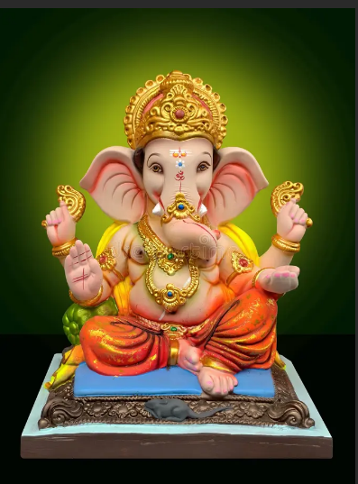

C) OUPUT
